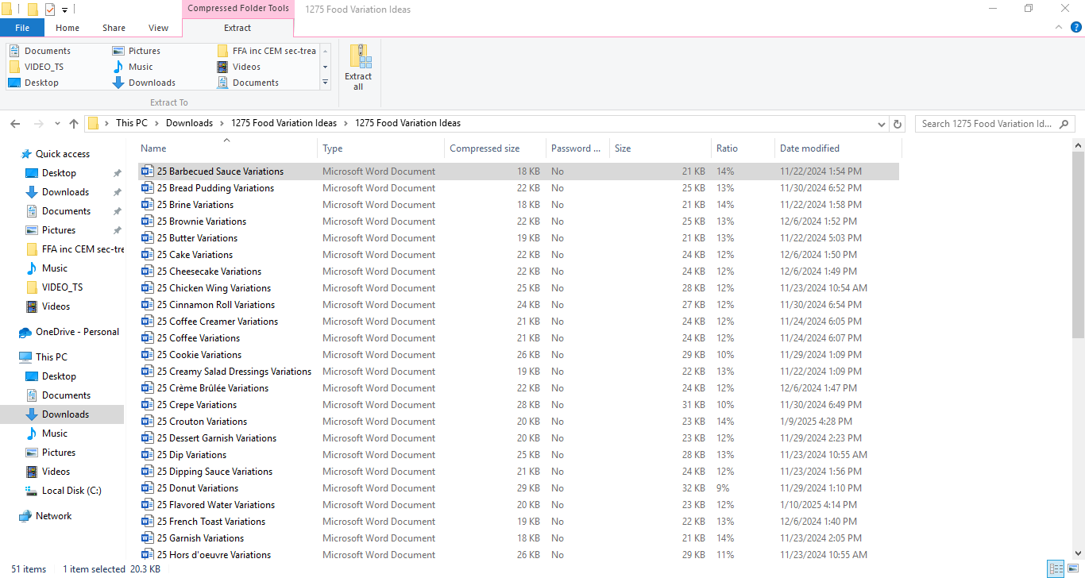

### **25 BBQ Sauce Variations**

### **Simple BBQ Sauces**

1. **Classic BBQ Sauce** - **1 cup ketchup : 1/4 cup brown sugar : 2 tablespoons vinegar : 1 tablespoon Worcestershire sauce**.
2. **Honey BBQ Sauce** - Add 1/4 cup honey for a touch of sweetness.
3. **Spicy BBQ Sauce** - Add 1-2 teaspoons hot sauce or cayenne pepper.
4. **Smoky BBQ Sauce** - Add 1 teaspoon smoked paprika for depth.
5. **Mustard BBQ Sauce** - Add 1/4 cup yellow or Dijon mustard for tang.
6. **Garlic BBQ Sauce** - Add 1-2 teaspoons garlic powder or fresh minced garlic.
7. **Maple BBQ Sauce** - Substitute brown sugar with 1/4 cup maple syrup.
8. **Apple Cider BBQ Sauce** - Use apple cider vinegar for a fruity tang.
9. **Brown Sugar BBQ Sauce** - Increase brown sugar for a caramelized sweetness.
10. **Herbed BBQ Sauce** - Add chopped thyme, rosemary, or oregano for a fresh flavor.

### **Unique BBQ Sauces**

1. **Pineapple BBQ Sauce** - Add 1/2 cup pineapple juice for tropical sweetness.
2. **Bourbon BBQ Sauce** - Add 1/4 cup bourbon for a boozy richness.
3. **Coffee BBQ Sauce** - Add 1/4 cup brewed coffee for a bold, earthy twist.
4. **Cherry BBQ Sauce** - Add 1/4 cup cherry preserves or juice for fruity depth.
5. **Sriracha BBQ Sauce** - Stir in 1-2 tablespoons sriracha for heat.
6. **Asian-Inspired BBQ Sauce** - Add 1 tablespoon soy sauce and a splash of rice vinegar.
7. **Cilantro Lime BBQ Sauce** - Add chopped cilantro and lime juice for a fresh, zesty flavor.
8. **Chipotle BBQ Sauce** - Add 1 teaspoon chipotle in adobo for smoky heat.
9. **White BBQ Sauce** - Mix mayonnaise with vinegar, garlic, and black pepper for a Southern twist.
10. **Mango BBQ Sauce** - Add 1/4 cup pureed mango for a tropical flair.

### **Gourmet BBQ Sauces**

1. **Truffle BBQ Sauce** - Add a few drops of truffle oil for an earthy depth.
2. **Balsamic Fig BBQ Sauce** - Mix in 1/4 cup balsamic vinegar and fig preserves for a complex sweetness.
3. **Red Wine BBQ Sauce** - Add 1/4 cup red wine for a rich, full-bodied flavor.
4. **Black Garlic BBQ Sauce** - Stir in minced black garlic for a deep, umami twist.
5. **Saffron BBQ Sauce** - Add a small pinch of saffron for an exotic, luxurious touch.

### **Basic Recipe Directions for BBQ Sauces**

1. **Prepare the Base**: Combine the main ingredients in a medium saucepan over medium heat. For example, start with 1 cup of ketchup, 1/4 cup brown sugar, 2 tablespoons vinegar, and 1 tablespoon Worcestershire sauce for a classic BBQ base.
2. **Incorporate Variations**: Add the specific variation ingredients, such as honey, mustard, or smoked paprika, depending on the flavor you’re creating. Stir well to combine.
3. **Simmer the Sauce**: Bring the mixture to a gentle simmer and cook for 5-10 minutes, stirring occasionally, until the sauce thickens and flavors meld together.
4. **Adjust to Taste**: Taste the sauce and adjust seasoning as needed—add more sugar for sweetness, vinegar for tang, or spices for heat.
5. **Cool and Store**: Allow the sauce to cool to room temperature. Transfer it to an airtight container and refrigerate for up to 1-2 weeks.
6. **Serving Suggestions**: Use the BBQ sauce as a marinade, glaze, or dipping sauce for grilled meats, vegetables, or tofu. Brush on during grilling for a caramelized finish.

These sauces will elevate any grilled dish, from ribs and chicken to veggies and tofu.

Top of Form