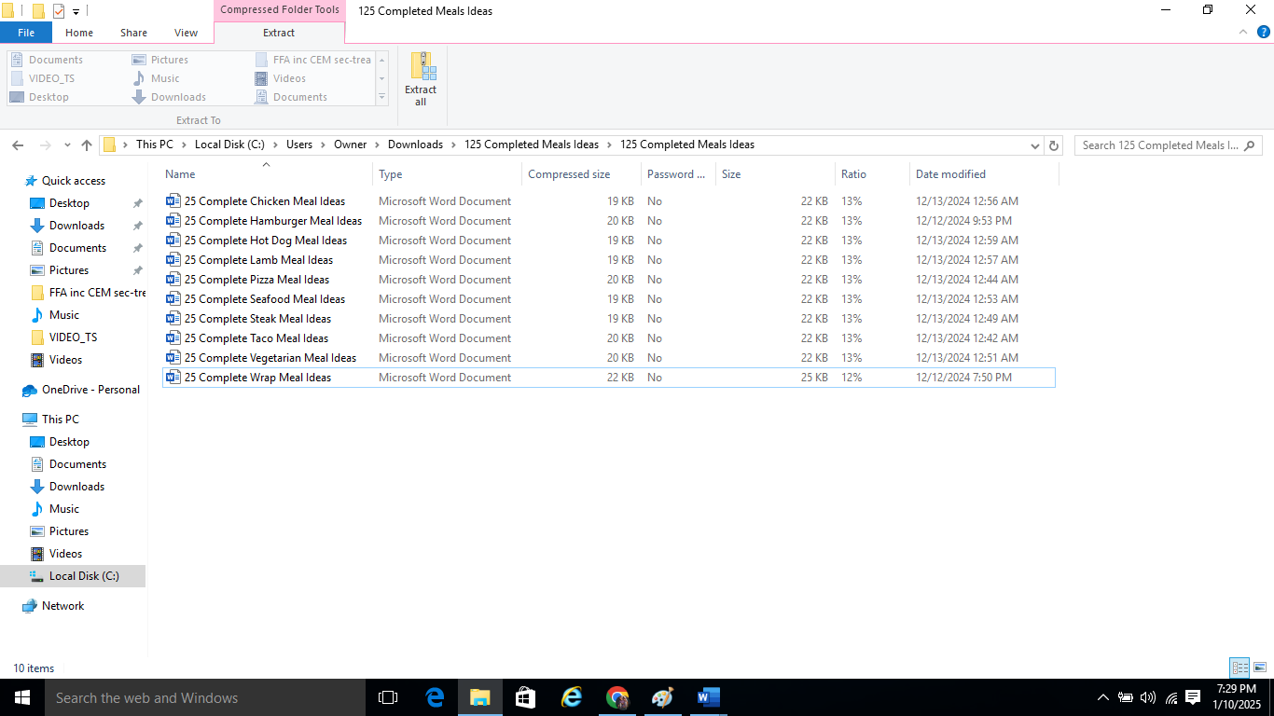

25 Complete Seafood Meal Ideas

Here’s a list of 25 complete meal ideas centered around seafood, including both fish and shellfish, organized into Simple, Unique, and Gourmet categories. Each category is tailored to different dining experiences: Simple for a family dinner table, Unique for a fancy restaurant, and Gourmet for a Michelin-star level experience.

### Simple (10) – Family Dinner Table

1. **Grilled Salmon Meal**
   * **Main**: Grilled salmon fillet with lemon and dill
   * **Sides**: Steamed rice and broccoli
2. **Fish and Chips Meal**
   * **Main**: Battered cod with tartar sauce
   * **Sides**: French fries and coleslaw
3. **Shrimp Scampi Pasta Meal**
   * **Main**: Shrimp scampi with garlic butter sauce over linguine
   * **Sides**: Garlic bread and Caesar salad
4. **Tuna Melt Sandwich Meal**
   * **Main**: Tuna melt with cheddar cheese on toasted sourdough
   * **Sides**: Potato chips and pickle spear
5. **Crab Cakes Meal**
   * **Main**: Classic crab cakes with remoulade sauce
   * **Sides**: Mixed greens and corn on the cob
6. **Lemon Garlic Shrimp Meal**
   * **Main**: Lemon garlic sautéed shrimp
   * **Sides**: Couscous and roasted asparagus
7. **Fish Tacos Meal**
   * **Main**: Grilled fish tacos with cabbage slaw and lime crema
   * **Sides**: Mexican rice and black beans
8. **Lobster Roll Meal**
   * **Main**: Lobster roll with buttered lobster meat on a toasted bun
   * **Sides**: French fries and coleslaw
9. **Coconut Shrimp Meal**
   * **Main**: Crispy coconut shrimp with sweet chili sauce
   * **Sides**: Jasmine rice and a small garden salad
10. **Baked Tilapia Meal**
    * **Main**: Baked tilapia with lemon and herbs
    * **Sides**: Mashed potatoes and green beans

### Unique (10) – Fancy Restaurant

1. **Seared Scallops with Lemon Butter Sauce Meal**
   * **Main**: Pan-seared scallops with lemon butter sauce
   * **Sides**: Risotto and roasted cherry tomatoes
2. **Paella Meal**
   * **Main**: Traditional Spanish paella with shrimp, mussels, clams, and chorizo
   * **Sides**: Crusty bread and a mixed greens salad
3. **Cioppino (Italian Seafood Stew) Meal**
   * **Main**: Cioppino with fish, shrimp, clams, and mussels in tomato broth
   * **Sides**: Garlic bread and a simple arugula salad
4. **Crab-Stuffed Sole Meal**
   * **Main**: Sole fillets stuffed with crab and baked in a creamy sauce
   * **Sides**: Wild rice pilaf and sautéed spinach
5. **Shrimp and Grits Meal**
   * **Main**: Southern-style shrimp and grits with bacon and scallions
   * **Sides**: Collard greens and cornbread
6. **Thai Coconut Curry Shrimp Meal**
   * **Main**: Shrimp in a creamy coconut curry sauce with vegetables
   * **Sides**: Jasmine rice and Thai cucumber salad
7. **Mussels in White Wine Sauce Meal**
   * **Main**: Mussels steamed in white wine, garlic, and herbs
   * **Sides**: French fries and a baguette for dipping
8. **Blackened Red Snapper Meal**
   * **Main**: Blackened red snapper with Cajun spices
   * **Sides**: Dirty rice and sautéed green beans
9. **Salmon Wellington Meal**
   * **Main**: Salmon Wellington with puff pastry and creamy spinach filling
   * **Sides**: Roasted potatoes and broccolini
10. **Swordfish with Mango Salsa Meal**
    * **Main**: Grilled swordfish topped with mango salsa
    * **Sides**: Coconut rice and a mixed greens salad

### Gourmet (5) – Michelin Star Level

1. **Butter-Poached Lobster Tail with Champagne Beurre Blanc Meal**
   * **Main**: Butter-poached lobster tail with champagne beurre blanc
   * **Sides**: Truffle mashed potatoes and sautéed haricots verts
2. **Seared Ahi Tuna with Wasabi Aioli and Seaweed Salad Meal**
   * **Main**: Seared ahi tuna with wasabi aioli and sesame seeds
   * **Sides**: Seaweed salad and soba noodles with sesame dressing
3. **King Crab Legs with Lemon Herb Butter Meal**
   * **Main**: Steamed Alaskan king crab legs with lemon herb butter
   * **Sides**: Roasted garlic mashed potatoes and grilled asparagus
4. **Octopus with Romesco Sauce Meal**
   * **Main**: Grilled octopus with smoky Romesco sauce and microgreens
   * **Sides**: Patatas bravas and a roasted beet salad
5. **Scallops with Black Truffle Risotto Meal**
   * **Main**: Seared scallops on a bed of black truffle risotto
   * **Sides**: Microgreens salad with champagne vinaigrette and crispy Parmesan tuile

These seafood meal ideas cover a broad spectrum of flavors and techniques, ranging from comforting family-style meals to internationally inspired dishes and luxurious, gourmet experiences.

Top of Form

Bottom of Form